REQUIREMENTS FOR THE EXPENDITURE TRACKING APP.
MY OWN VERSION
- Authentication (can sign up/login with Google and Facebook.)
- Language selection (French or English)
- Dark mode selection
- Ability to summarize user expenditures upon request.
- Display total expenditure by categories (e.g., food, transport) with graphs if possible (check spendee app)
- Summarize monthly expenditures, including total monthly spending and what they spent the money on.
- Provide a form for users to set and update their budget.
- Collect and track user Momo expenditures with user permission.
- Provide summery based on Momo transactions.
• Recommend spending habits based on the user's occupation or job type.
• Provide tips to balance spending.
• Allow users to export their expenditure summaries and reports as PDF files.
LINK TO MY FLOW CHART ON LUCID CHART
https://lucid.app/lucidchart/f110a41d-862f-4aa4-80b7-848957361324/edit?invitationId=inv_fd3ecf50-8f0a-4702-aa42-b97bb396f580
SOME EXISTING SYSTEMS
Jupiter Money design.
https://jupiter.money/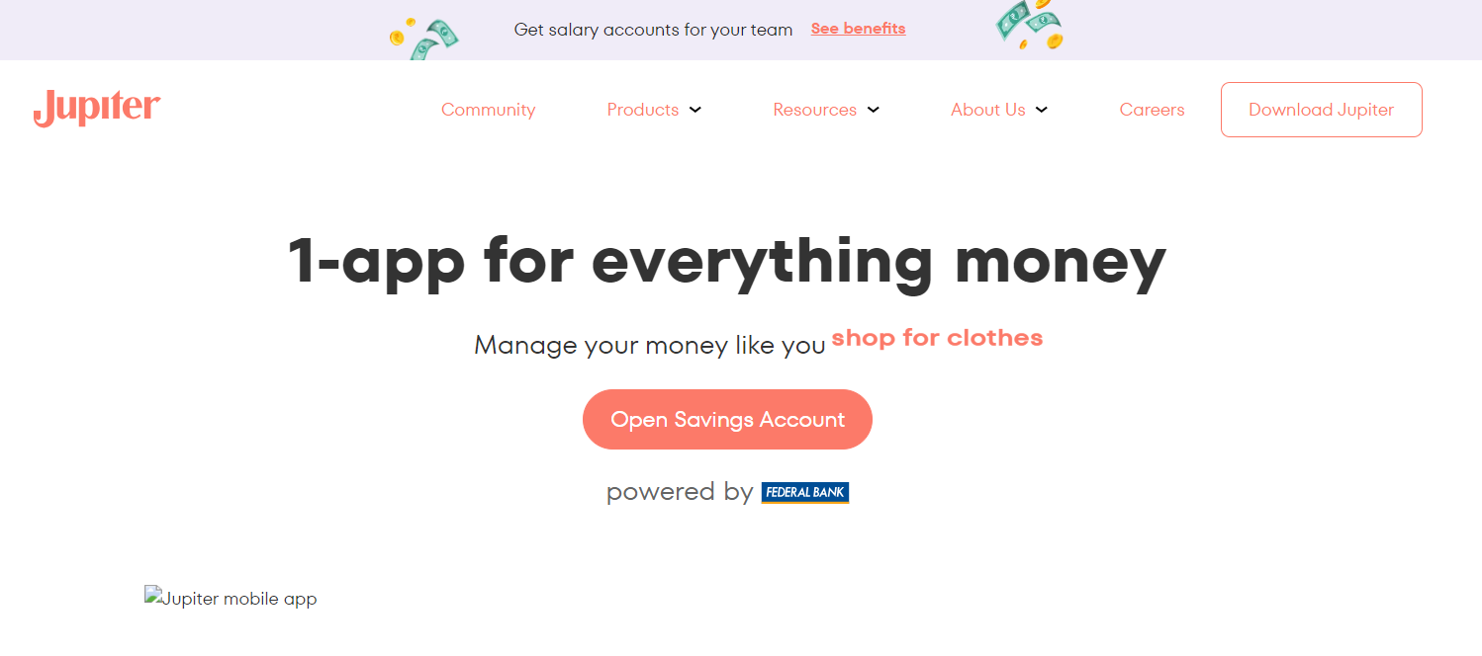

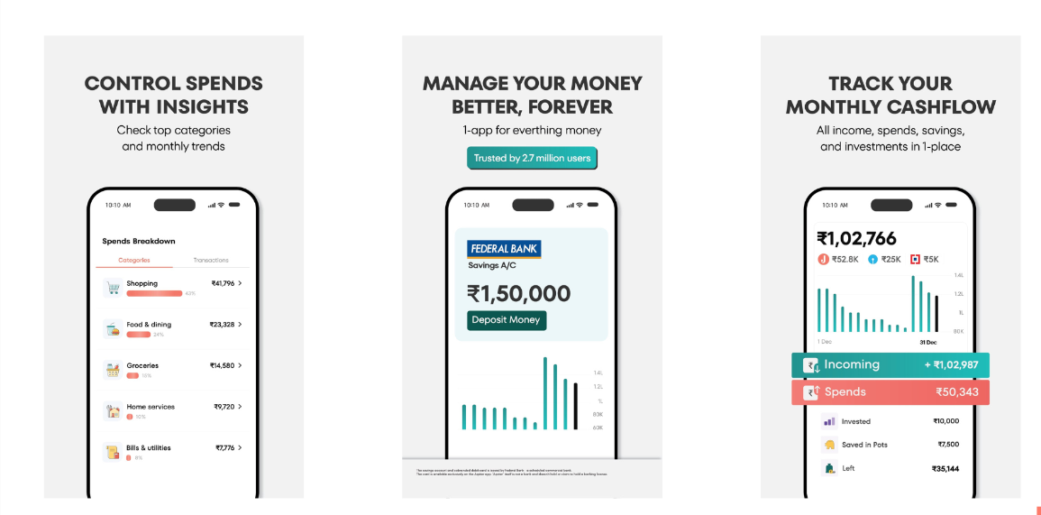

2) Spendee
I took most of my reference from this one
